EyeQ Documentation
This documentation explains all the pages and their functionalities for the EyeQ application.
- Running the application in current PC
Double-click on the desktop shortcut named ABIUnifiedApp to run the application.
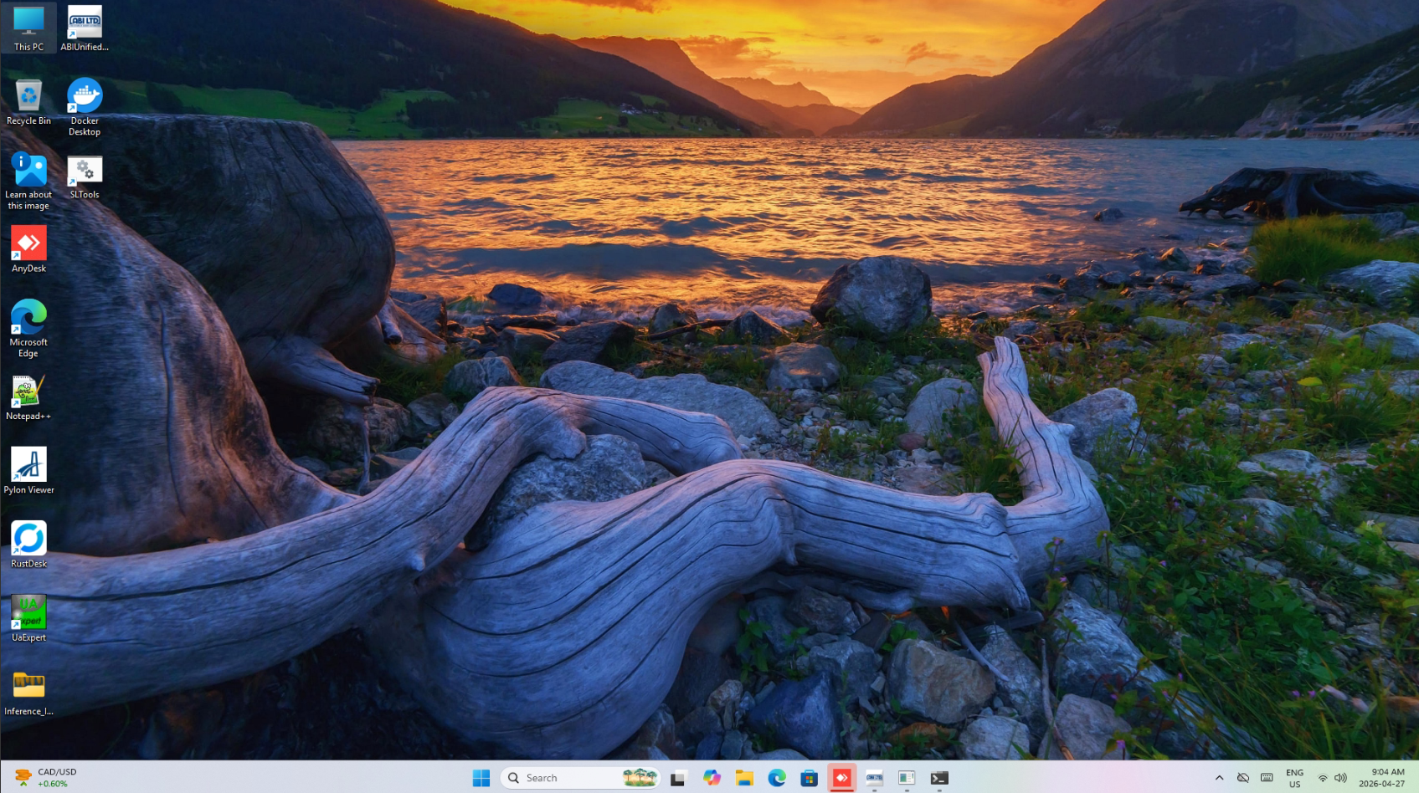

- Home
The home page of the application shows the following information.
  - Active Recipe that is currently running in the system.
  - The number of scans, total products, average products per scan, total number of defects, number of defective products for the last hour.
  - The measurements of the product (width, length and height) are also shown in the home page. The average, target and the difference in percentage between the average and the target values are also shown for the above measurements. The stats will appear in green if they are in between threshold values and in red if they are out of threshold values.
  - In the bottom bar, we can see the conveyor speed, the buttons for toggling on/off vision lights and executing blowoff to clean the lens of the cameras.
  - On the right side, we can see the vision monitor which shows the 3D image of the recently processed scan with products and the 2D tab shows the conveyor with passing products with color. The vision monitor also shows the direction that the conveyor and products are moving.
  - There is a Live toggle which can be turned off to view historical data (more than an hour) by selecting the Recipe, Date Range, Start Time and End Time and then clicking on Update Stats button. By default, these fields are disabled as the app shows the data for the last hour but after toggling the Live button the user can view the historical data.
  - Clicking on the Export button will export all the product data for the selected recipe and timeframe as a csv (comma separated values) file.
Please find the screenshots below to check the live and historical data example.
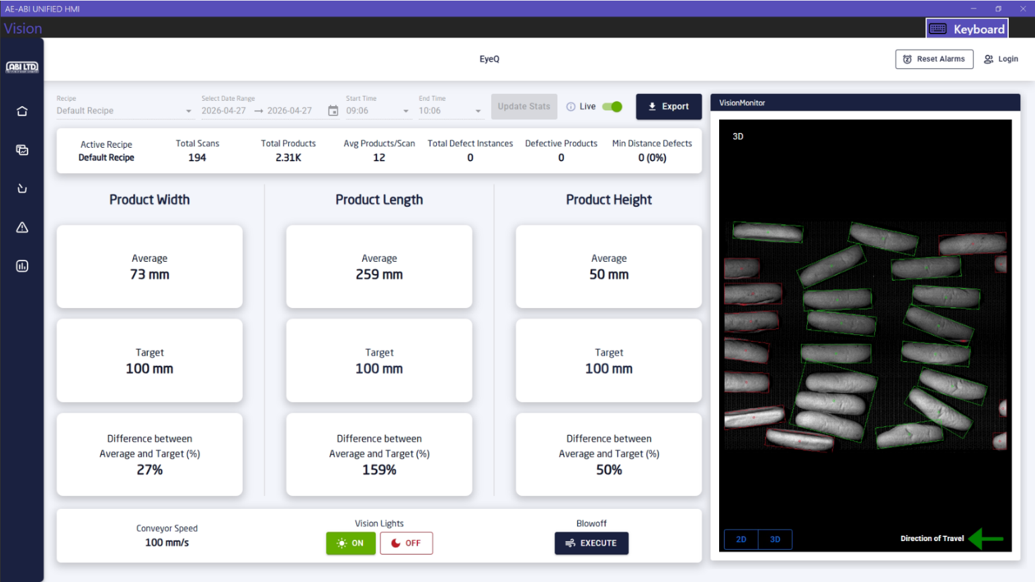
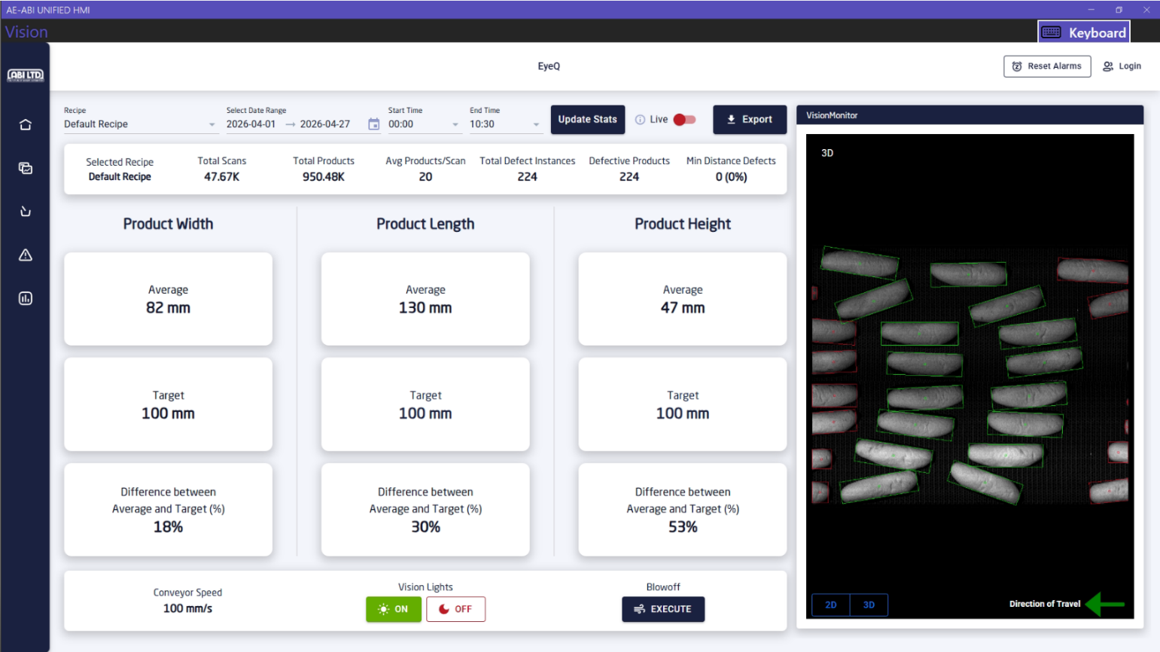
- Trends
The trends page of the application has several tabs. The filtering and live toggling works the same as the home page. Please find the description of all the tabs and the data each tab is displaying below.
- Measurements
The measurements tab shows the average width, length, and height of the products per scan. As you can see from the screenshot below, the average width of products was 73 mm for the frame scanned at 2026-04-27, 10:00:18 am. The charts can be zoomed in by selecting a portion and dragging on the HMI. The home icon can be pressed to reset the chart to default position.
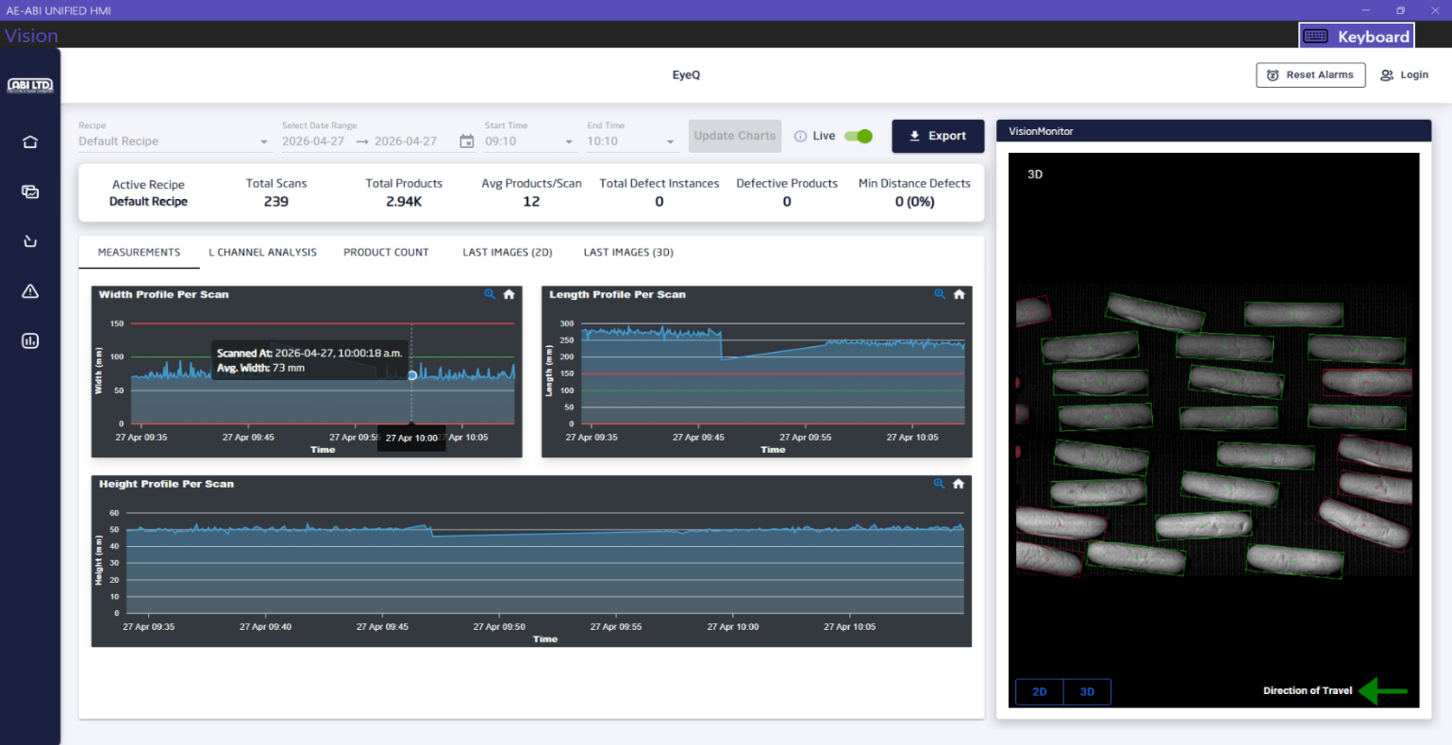
- L Channel Analysis
The L channel analysis shows the average L* values for products scanned at a specific time. We are using 2D cameras to calculate that value for the products. From the screenshot below, we can see that the average L* value was 65.33 for the products scanned at 2026-04-27, 10:06:09 am.
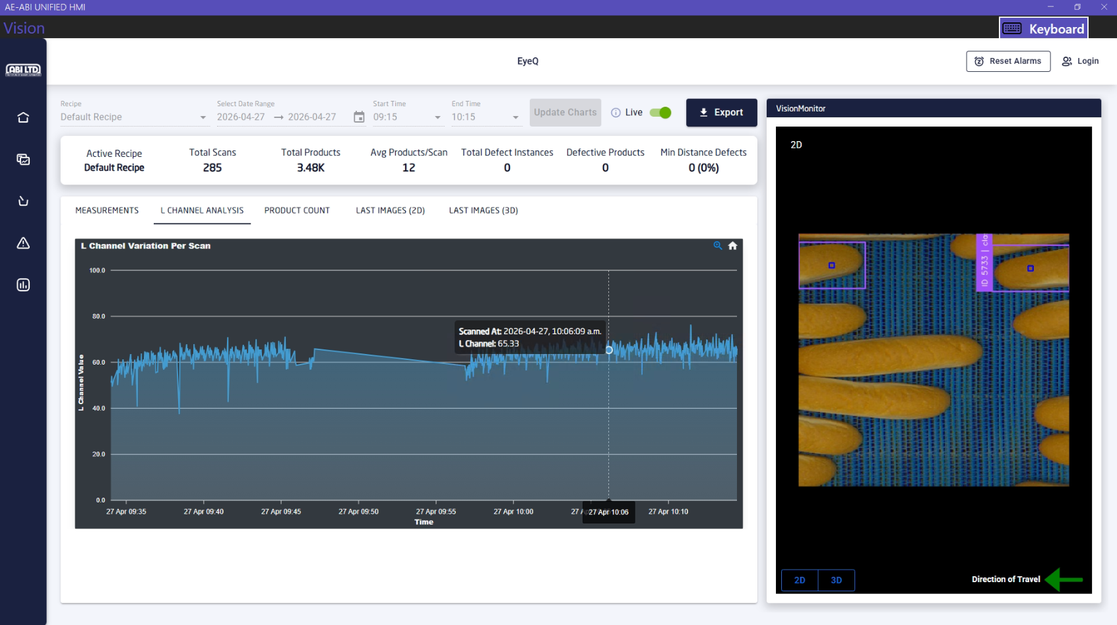
- Product Count
The product count tab shows the number of products per scan. From the screenshot below, it can be seen that there were 17 products for the products scanned at 2026-04-27, 10:08:33 am.
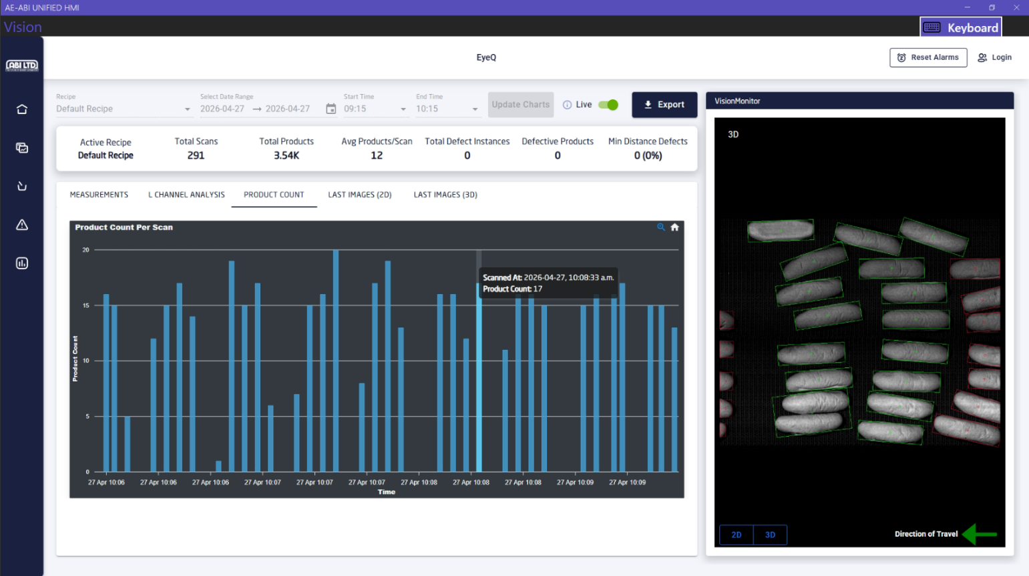
- Last Images
The last images (2D) and last images (3D) tabs show the images captured during the last 24 hours. The latest images are shown first and there is pagination support to view the previous images. It also shows the time when the image was captured, and an image can be enlarged by clicking on it to view it more clearly. Please find the screenshots below.
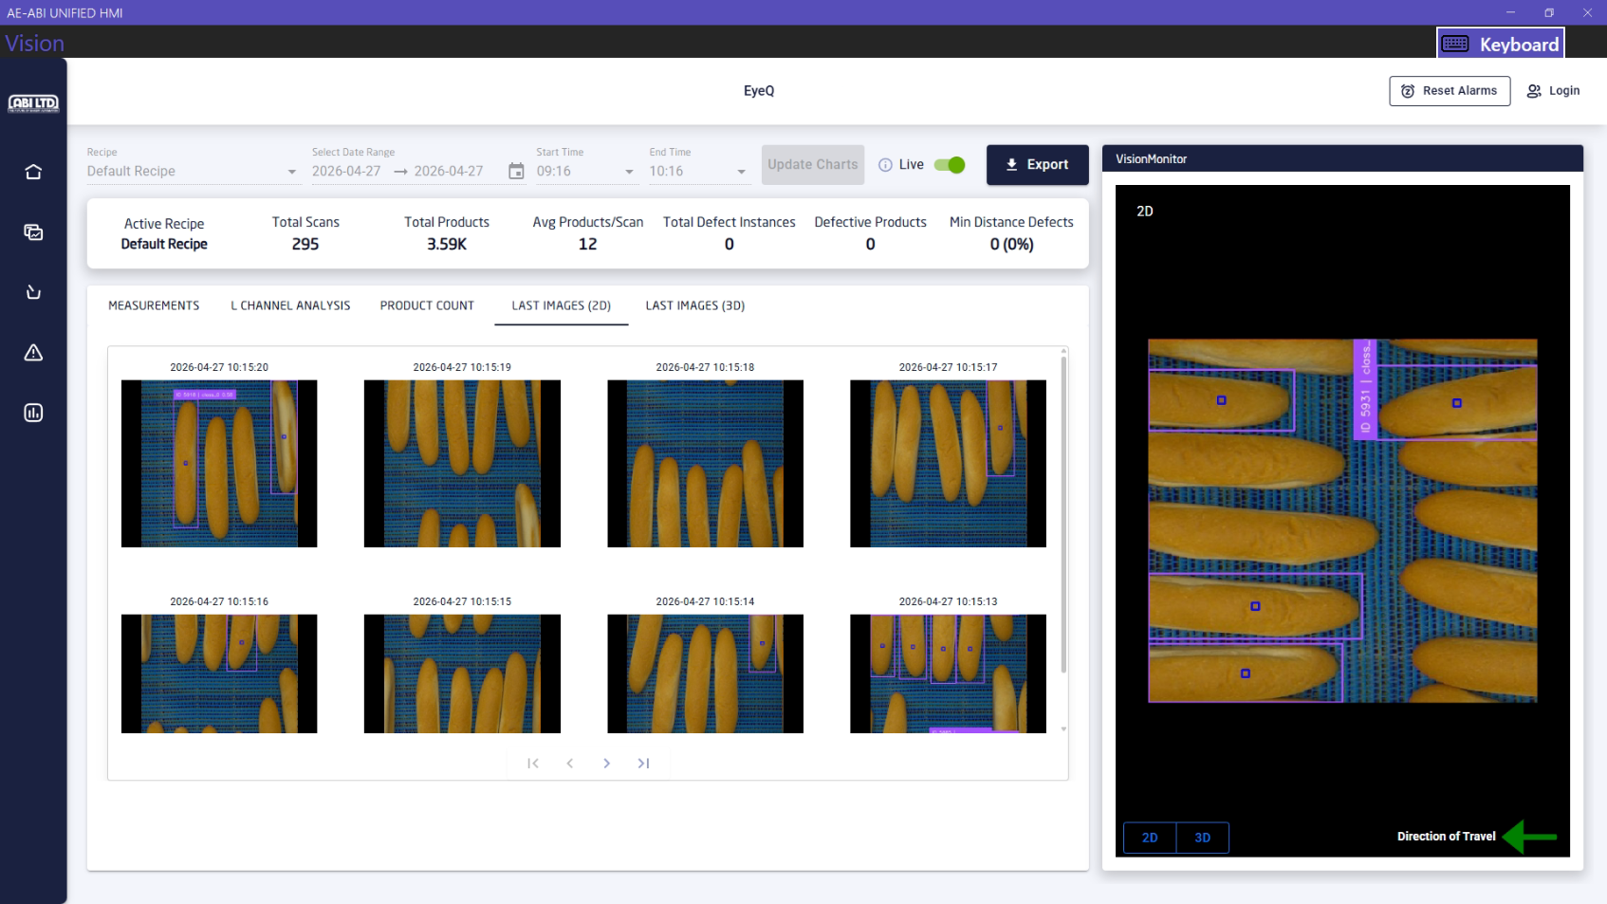
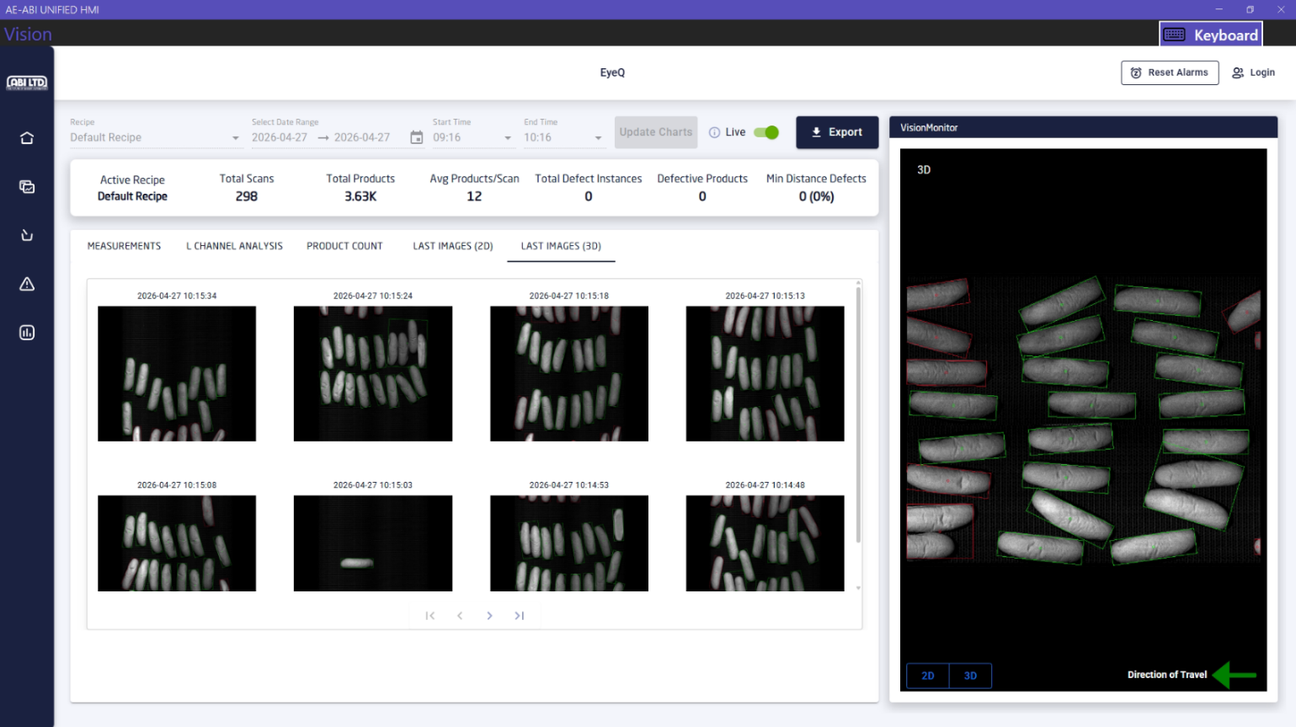
- Recipes
The recipes page shows all the recipes along with total number of products produced and number of products that had defects for each recipe since that recipe was active. It also shows the active recipe that is currently running with a darker blue background. As there is only one recipe available for now, the screenshot below is showing that one.

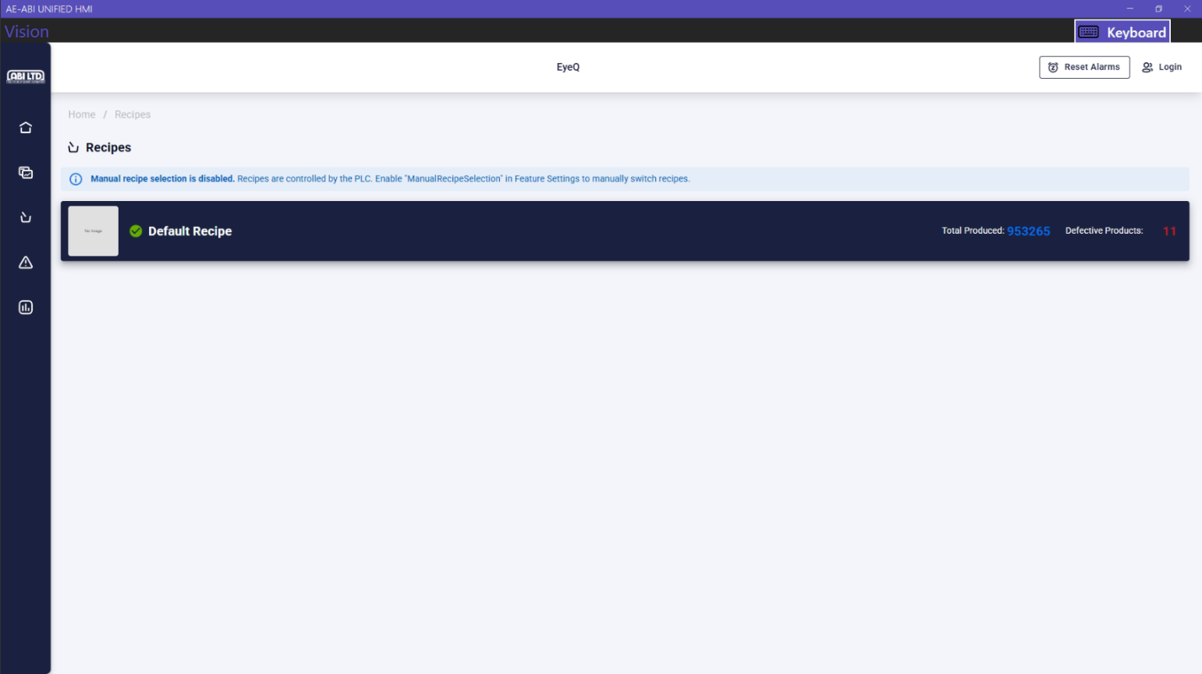

By default, the active recipe is set and controlled by the PLC. To enable recipe selection manually, go to Settings > Feature Settings and enable the “ManualRecipeSelection” feature.
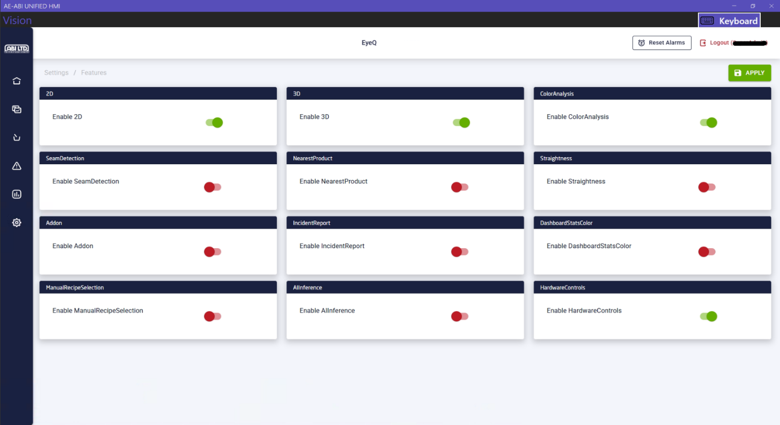

- Logs
The logs page shows the system logs and user action logs for the application along with any defects for products that were detected while processing the images. The user can click on the Clear Errors button at the right of the page to clear the errors.
The system logs can be filtered by severity and can be exported using the Export button.

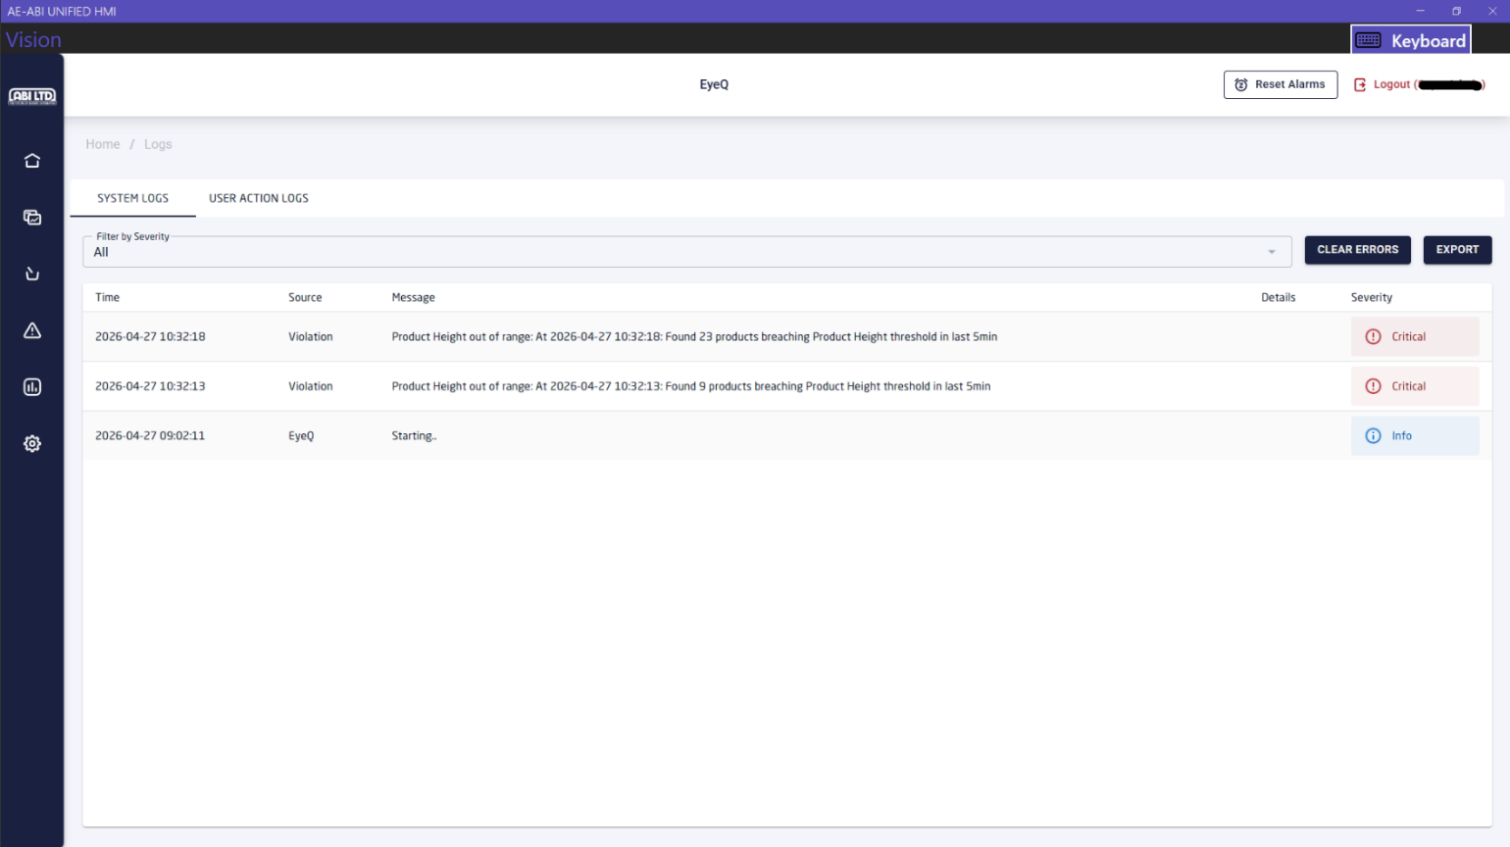
The user action logs show what actions were taken by a user while using the system such as login, logout time, changes in threshold for a recipe. These logs can be filtered by start and end date, user, and action. They can also be exported using the Export button.
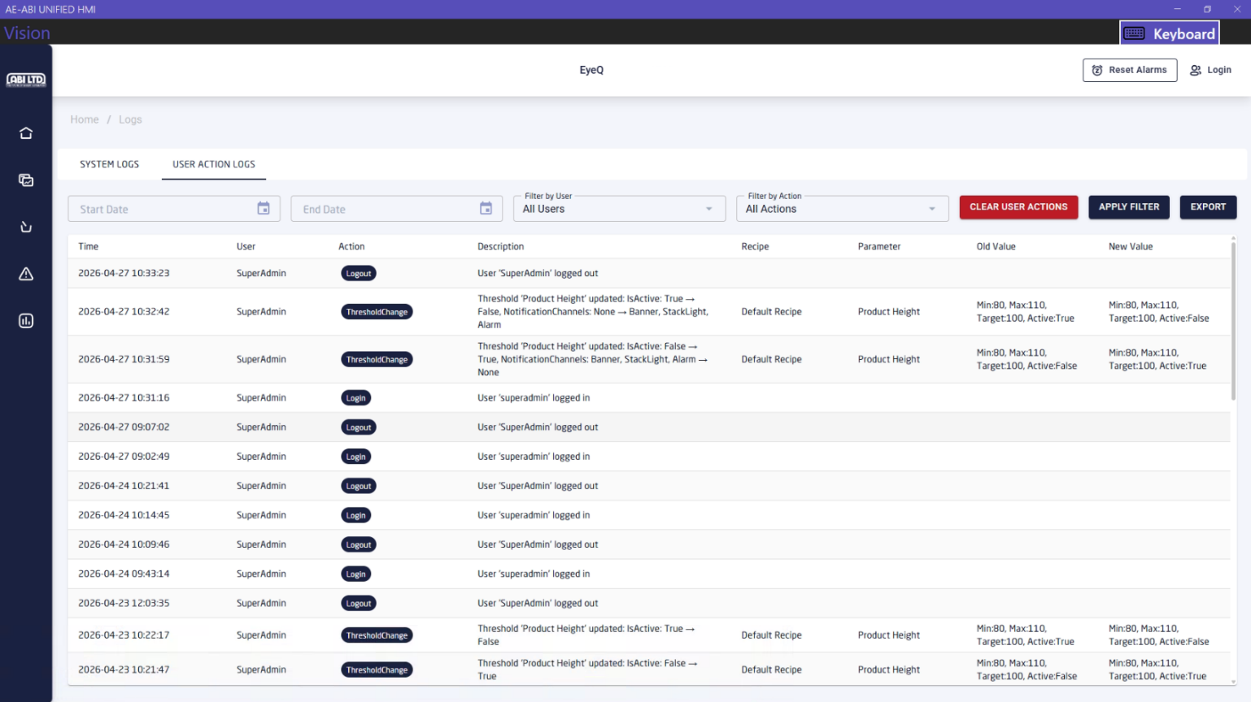

- Thresholds
The thresholds page shows the different types of thresholds that have been set up for the active recipe. There are 8 thresholds for now per each recipe. They are Product Height, Product Width, Product Length, Straightness (ratio of product width vs length), Seam Presence (if the product has seam), Minimum Distance Between Products, Products Per Board and Boards Per Hour. Each threshold has the following fields.
  - Name: Name of the threshold
  - Target: Target value for the threshold
  - Min: Minimum accepted value for the threshold
  - Max: Maximum accepted value for the threshold
  - Number of Defects: The number of defects that need to be passed before an alarm is raised
  - Defect interval (min): The amount of time the system will check to decide whether to raise an alarm. For example, if the number of defects is 50 and defect interval is 5 minutes then an alarm will be raised if in the last 5 minutes the number of defects for that specific threshold is 50 or higher
  - Message: The message that will be displayed in the alarm
  - Notify by: The notification channels (Banner, Stack light, Alarm buzzer) by which the user will be alerted. There is a Reset Alarms button at the top right of the screen which will reset all the alarms
  - Active: Whether or not the threshold is active for the recipe. The threshold must be active to log the defects of products in the application
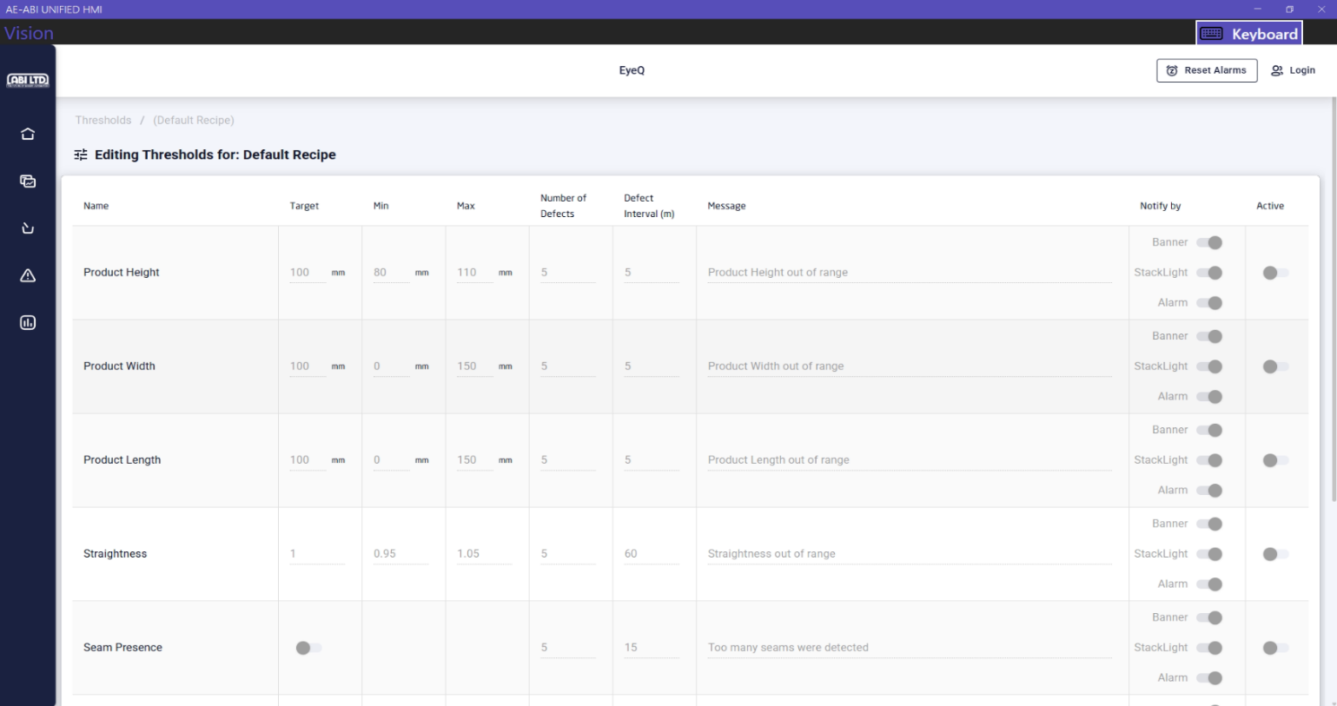
By default, the users/operators can only view the thresholds for the active recipe. To edit them, the user needs to login as an admin. The login method and threshold changing process will be described later in the document.
- Login
The Login button is located at the top-right of the application. To change threshold values, 3D settings for the camera, editing general settings the user needs to login as Admin. The credentials for the admin user are provided below.
Username: gonnellaadmin
Password: gonnella@123
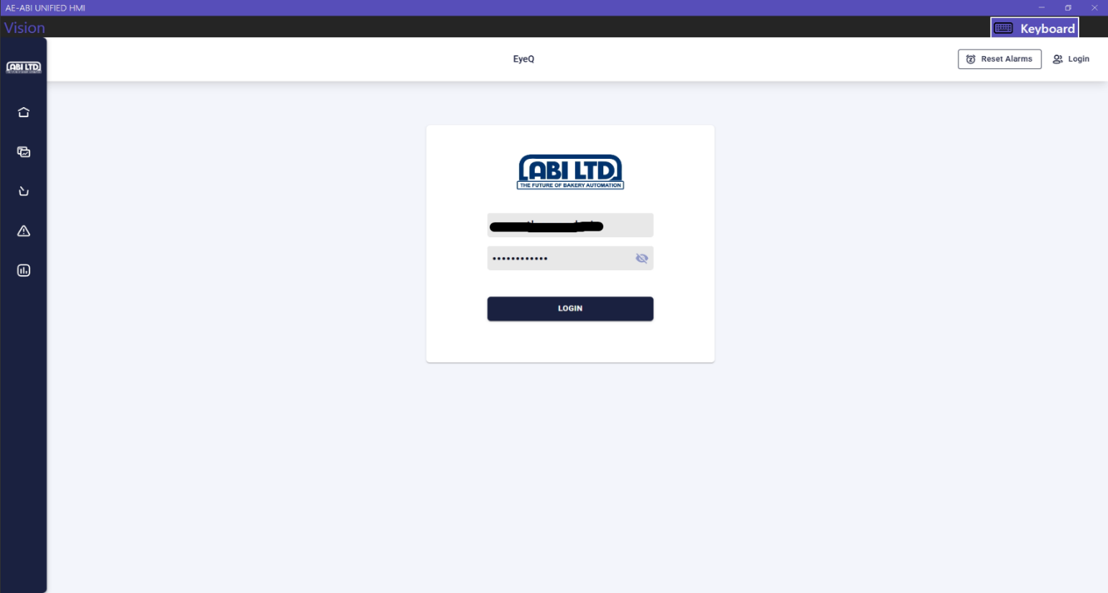
- General Settings
The general settings page will only appear once the user is logged in. Click on the Settings > General Settings tab to view the settings. Please look at the screenshots below.

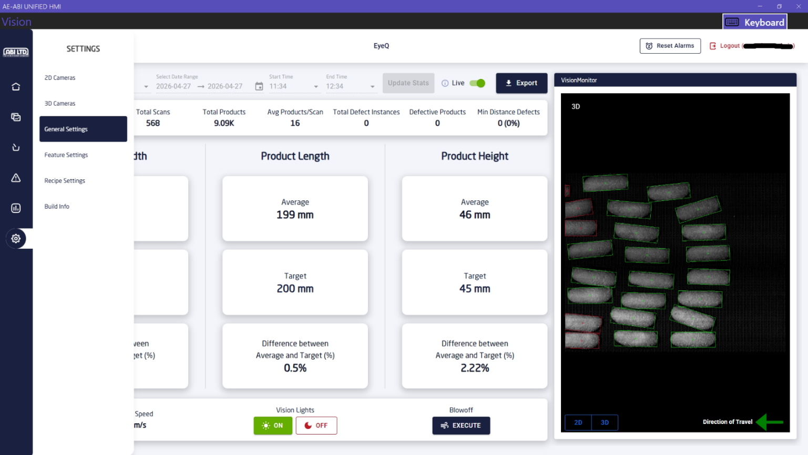

We can set the company name, machine name, location for saving images captured by the application from the general settings page.
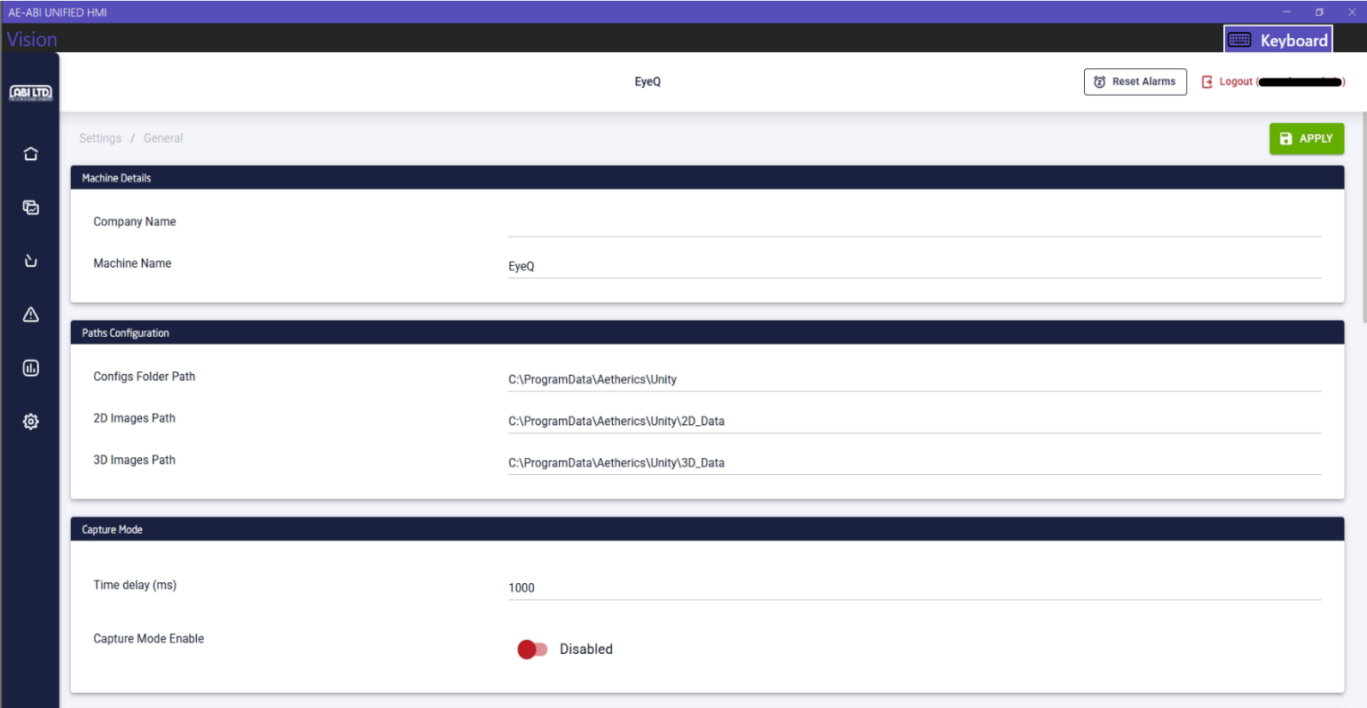

The preview settings of the images, the trigger for capturing the images (software or hardware) and the scan line source (time-based or encoder-based) can also be set from the general settings page.
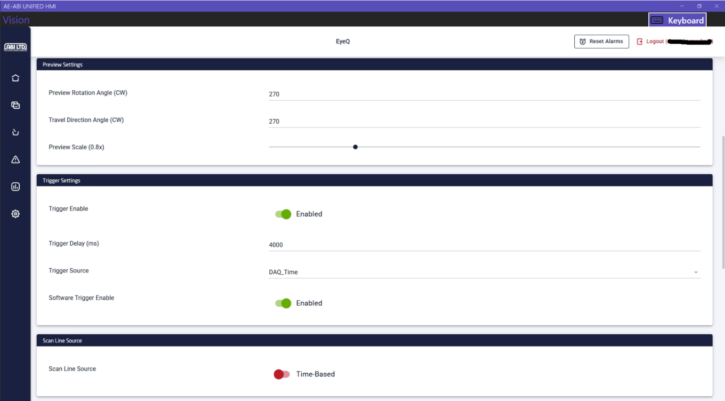

The other settings available are the conveyor height (mils), carrier type (belt or pan), whether the system is running in production mode or calibration mode. Some of the hardware settings such as turning on/off the vision lights, resetting the Hermary cameras and blowoff settings are also available in the general settings page. Please note that although the values can be changed, the current values are set in a way to ensure highest performance of the EyeQ system.
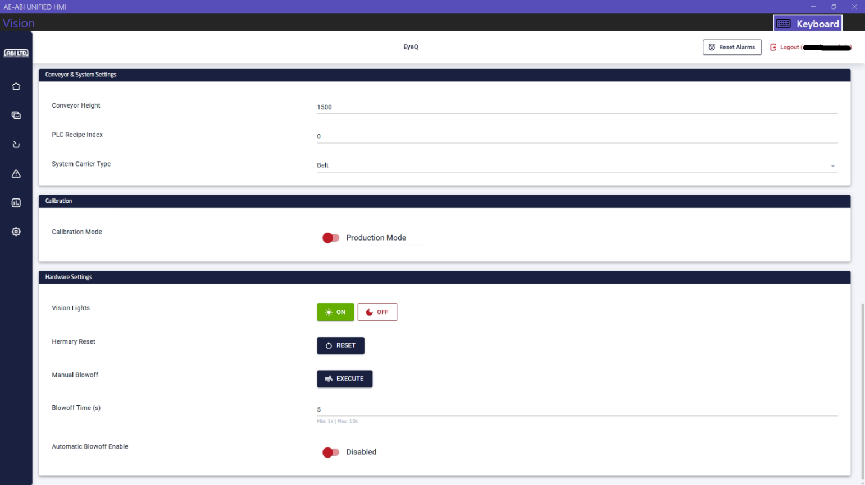

- Feature Settings
The feature settings page will only appear once the user is logged in. Click on the Settings > Feature Settings tab to view the settings. Please look at the screenshots below.

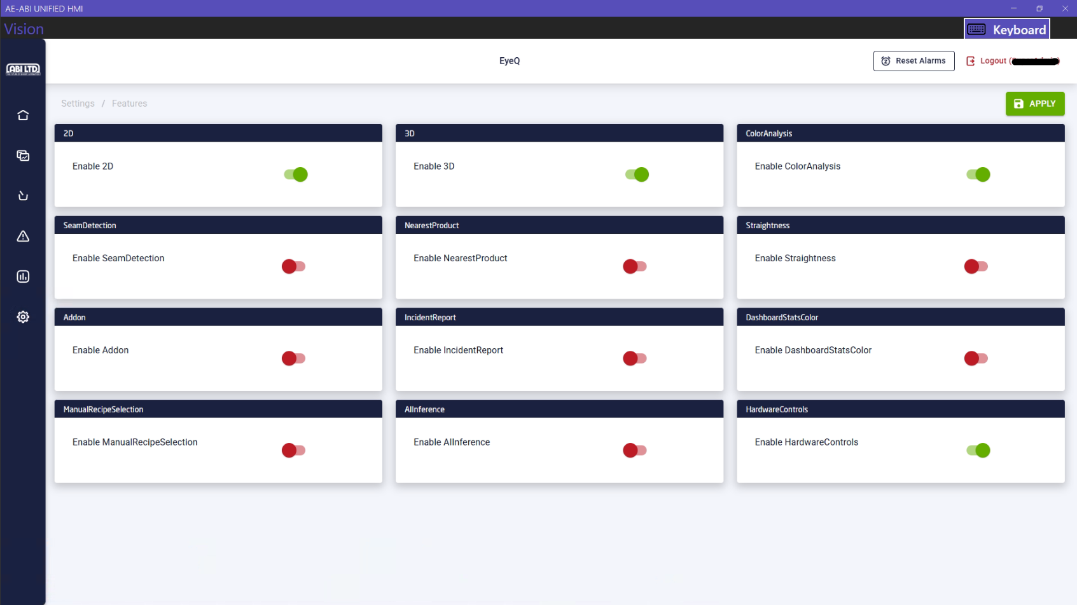

- Camera List
The 2D and 3D camera list will also appear when the user is logged into the system. Click on the Settings > 2D Cameras and Settings > 3D Cameras to view the cameras. We can change the settings of the cameras such as IP addresses, exposure, ROI, scan length etc. from these pages.
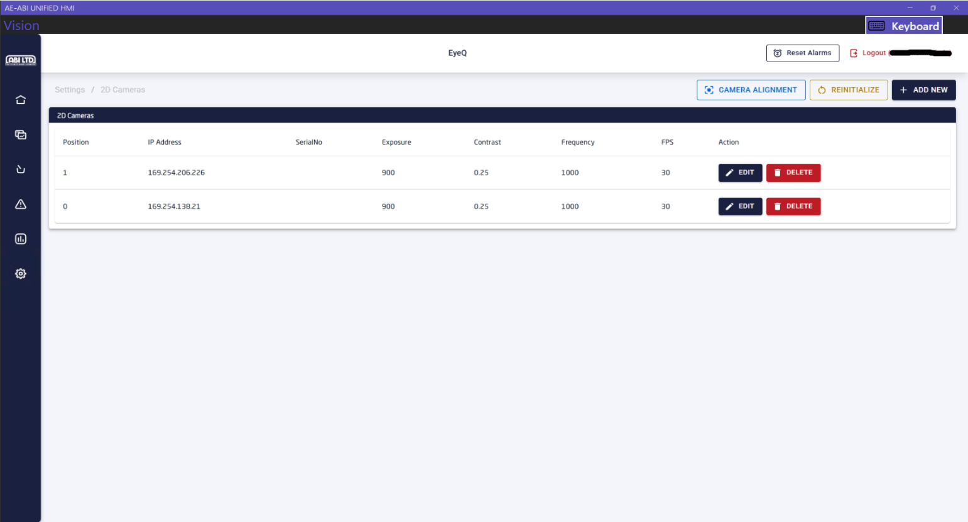
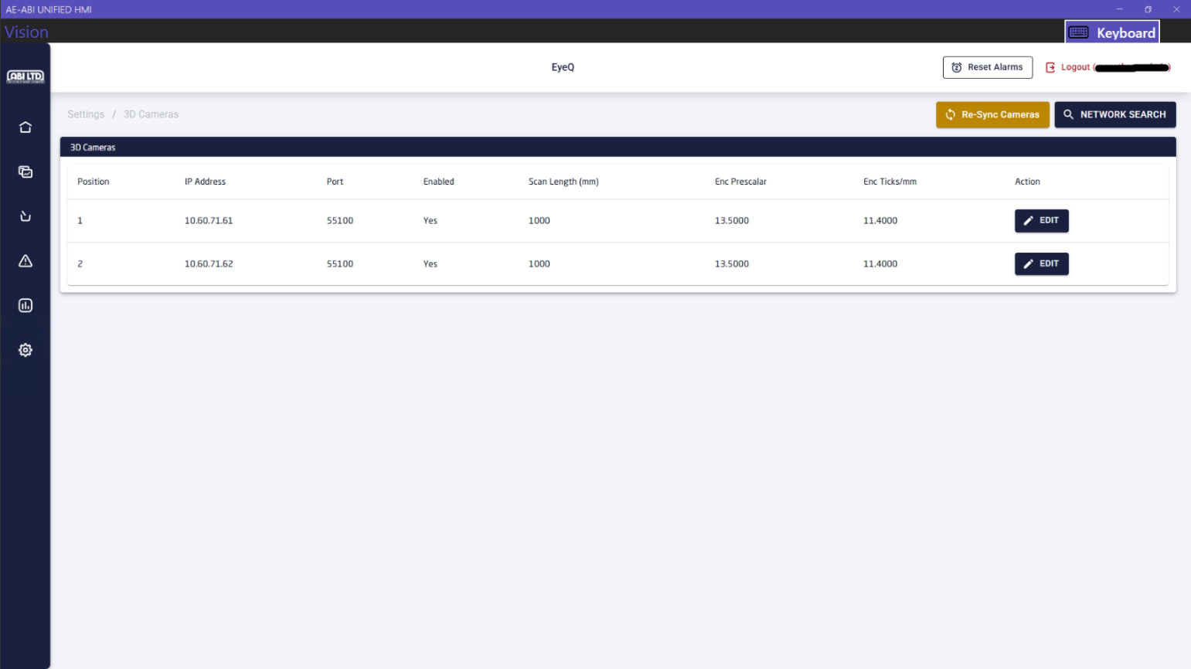

- Changing the settings of the recipes
To change the settings or thresholds for a recipe, login as Admin using the credentials provided before in the doc and go to Settings > Recipe Settings page. It will list all the recipes in the system, and we can change settings for a specific recipe from this page.

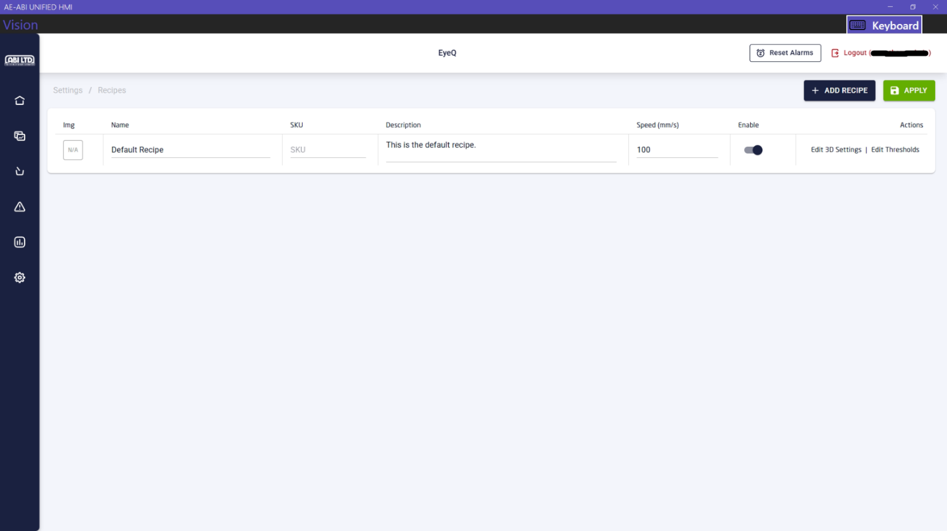

Click on the Settings > Recipe Settings > Edit 3D settings button to change the capture settings for that recipe such as minimum and maximum acceptable product dimensions, product acceptance and rejection color, pan settings (if there are products running on top of pans). After changing the settings, click on APPLY button to save the changes.
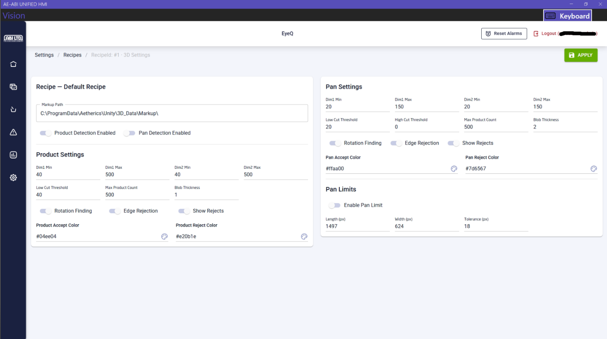
Click on the Settings > Recipe Settings > Edit Thresholds buttons for specific recipe, then set the values. After changing the thresholds, click on APPLY button to save the changes.
